2253 CFGS Web Application Development

Module 2 – Data Bases

UF2 – SQL Language: DDL and DML
NF4 – Data Manipulation Language
ACTIVITY

ACTIVITY DONE BY  Aaron Andal | 1DAW

Activity 9: Using SELECT statements

Description

Implement next SQL DML statements in AGENCY database.

The Entity-Relationship:

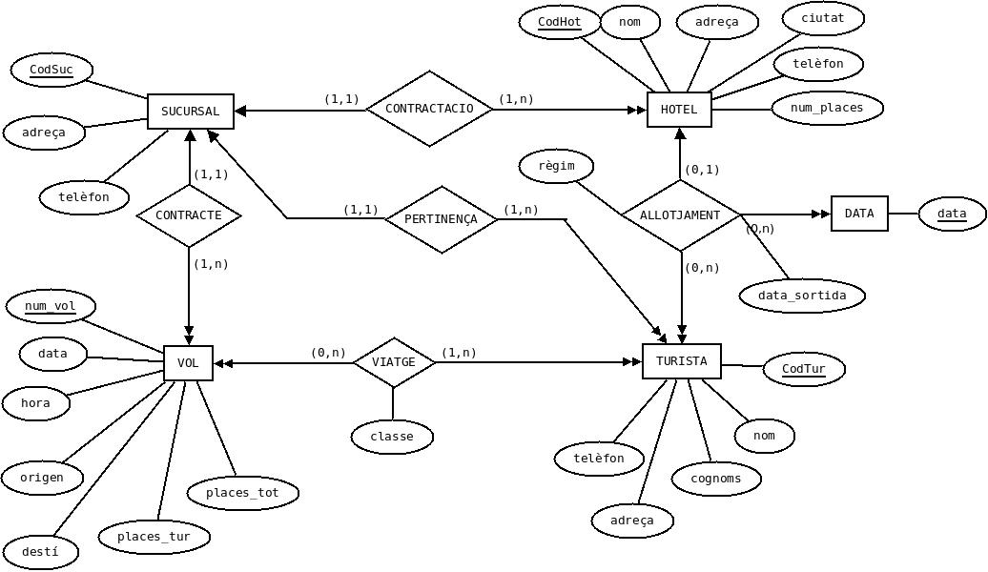

And the relational model:

SUCURSAL (CodSuc, adreca, telefon)

VOL (num_vol, data, hora, origen, desti, places_tur, places_tot, CodSuc)
ON {CodSuc} REFERENCIA SUCURSAL (CodSuc)

HOTEL (CodHot, nom, adreça, ciutat, telefon, num_places, CodSuc)
ON {CodSuc} REFERENCIA SUCURSAL (CodSuc)

TURISTA (CodTur, nom, cognoms, adreca, telefon, CodSuc)
ON {CodSuc} REFERENCIA SUCURSAL (CodSuc)

ALLOTJAMENT (CodTur, data_ini, CodHot, data_sortida, regim)
ON {CodTur} REFERENCIA TURISTA (CodTur)
ON {CodHot} REFERENCIA HOTEL (CodHot)

VIATGE (CodTur, num_vol, classe)
ON {CodTur} REFERENCIA TURISTA (CodTur)
ON {num_vol} REFERENCIA VOL (num_vol)

1) Select the tourists (all the information) ordered firstly by surname and secondly by name.

SELECT * FROM TURISTA ORDER BY TURISTA.cognoms, TURISTA.nom

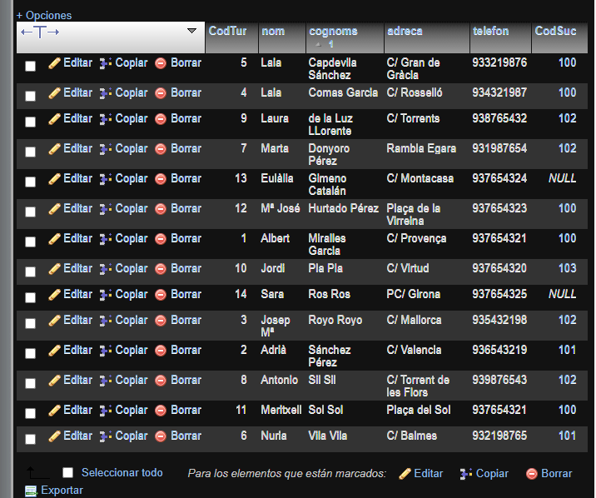

2) Select the hotels (code and name) that work with the agency (sucursal) 101.

SELECT
HOTEL.CodHot,
HOTEL.nom
FROM
HOTEL
WHERE
HOTEL.CodSuc = 101

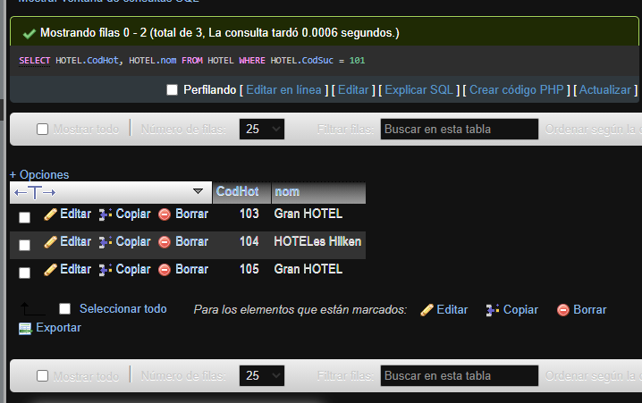

3) Select the tourists (code, name and surname) who belong to the agency (sucursal) located at C/ Sants'.

SELECT
TURISTA.CodTur,
TURISTA.NOM,
TURISTA.cognoms
FROM
TURISTA
JOIN
SUCURSAL
ON
TURISTA.CodSuc = SUCURSAL.CodSuc
WHERE
SUCURSAL.adreca = 'C/ Sants'

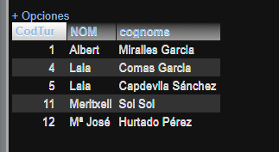

4) Select name, surname, address and phone of all the tourists who have been at a hotel on half board (mitja pensió) between 2013-09-03' and '2013-09-08' both included.

SELECT DISTINCT
(TURISTA.nom),
TURISTA.cognoms,
TURISTA.adreca,
TURISTA.telefon
FROM
TURISTA
JOIN
ALLOTJAMENT
ON
TURISTA.CodTur = ALLOTJAMENT.CodTur
WHERE
ALLOTJAMENT.regim = 'mitja pensió' AND ALLOTJAMENT.data_sortida >= '2013-09-03' AND ALLOTJAMENT.data_ini <= '2013-09-08'

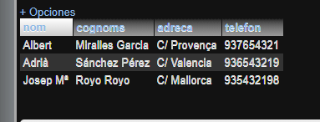

5) Select all the tourists (all the information) whose name begins by 'L'.

SELECT
*
FROM
TURISTA
WHERE
TURISTA.nom LIKE "L%"

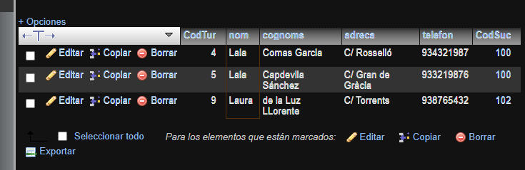

6) Select all the tourists (code, name and surname) who have not hired any flight.
SELECT
TURISTA.CodTur,
TURISTA.nom,
TURISTA.cognoms
FROM
TURISTA
WHERE
TURISTA.CodTur NOT IN(
SELECT
VIATGE.CodTur
FROM
VIATGE)
;

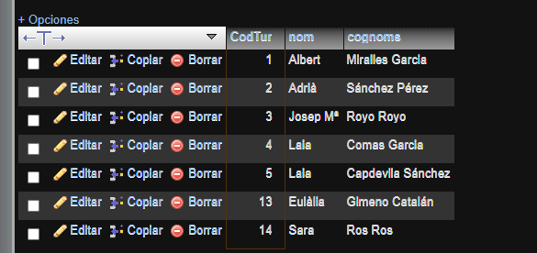

7) Select all the tourists (name and surname) who have not traveled in flight number 1000.

SELECT
TURISTA.nom,
TURISTA.cognoms
FROM
TURISTA
WHERE
TURISTA.CodTur NOT IN(
SELECT
VIATGE.CodTur
FROM
VIATGE
WHERE
VIATGE.num_VOL = 1000
);

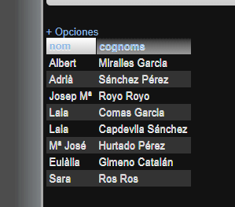

8) For every hotel select the tourist name and surname in the way surname1 surname2, name (for example: Sil Sil, Antonio), hotel name in capital letters, check-in date and number of days that have stayed in the hotel. The list must be ordered firstly by the hotel name and secondly by the tourist surnames. You have to use time functions.

SELECT
CONCAT(
TURISTA.cognoms,
' , ',
TURISTA.nom
),
UPPER(HOTEL.nom),
ALLOTJAMENT.data_ini,
(
ALLOTJAMENT.data_sortida - ALLOTJAMENT.data_ini
)
FROM
TURISTA
JOIN
ALLOTJAMENT
ON
TURISTA.CodTur = ALLOTJAMENT.CodTur
JOIN
HOTEL
ON
HOTEL.CodHot = ALLOTJAMENT.CodHot
ORDER BY
HOTEL.nom,
TURISTA.cognoms

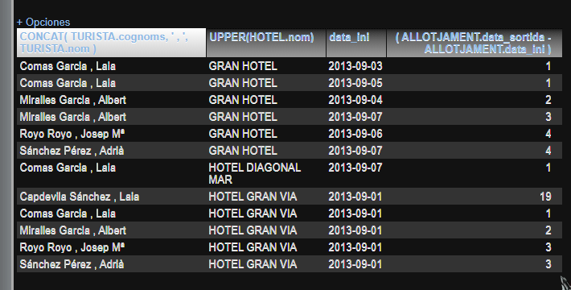

9) Select a completed list of all the tourists with address and phone number of the agency where they are assigned. The list must contain information of the tourists who are not assigned to any agency.

SELECT
TURISTA.CodTur,
TURISTA.nom,
TURISTA.cognoms,
TURISTA.adreca,
TURISTA.telefon,
SUCURSAL.CodSuc,
SUCURSAL.adreca,
SUCURSAL.telefon
FROM
TURISTA
LEFT JOIN
SUCURSAL
ON
TURISTA.CodSuc = SUCURSAL.CodSuc

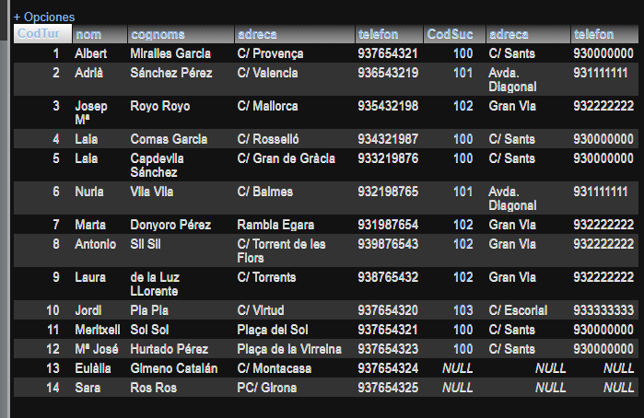

10) Select the flights which have been contracted for more than 2 tourists. The select must contain the flight number, the city from where the flght comes and the destination.

SELECT
VIATGE.num_VOL,
COUNT(*) AS num_passatgers,
VOL.origen,
VOL.desti
FROM
VIATGE
JOIN
VOL
ON
VIATGE.num_VOL = VOL.num_VOL
GROUP BY
VIATGE.num_VOL
HAVING
num_passatgers > 2

